OO Analysis and Design Lab Week 1

Name: Piotr Kawalec

Class: Web Development 2

Q1 Please refer to the Public University Registration System Problem Statement below and answer the given questions

1. *Identify the additional events to which the automated system must now respond.*- Instructor submits grades  
   - Record office produce grade’s report
2. *Modify the event table below to incorporate these events. Imagine that each system input associated with an event arrives individually.*

|  |  |  |  |  |  |
| --- | --- | --- | --- | --- | --- |
| **EVENT NUMBER** | **EVENT DESCRIPTION** | **SYSTEM INPUT** | **ACTOR PROVIDING INPUT** | **SYSTEM OUTPUT** | **ACTOR RECEIVING OUTPUT** |
| 5. | Instructors submit a grade sheet | Student’s grades | Instructor |  |  |
| 6. | Time to produce student/instructor’s grade report |  | Records office | Grade report | Student  Faculty member |

1. *List other events which might be included in a University Registration system of extended scope.*- Student may change his class.  
   - Student may be put on waiting list.  
   - Student may appeal his grades.
2. *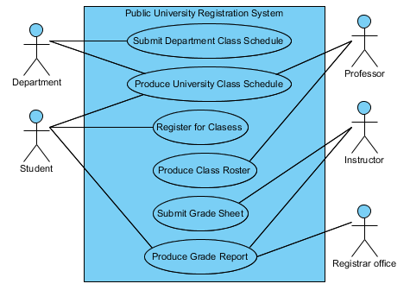Modify Use Case diagram to incorporate additional requirements*
3. Prepare a use case narrative for the additional events in the Public Registration system.

|  |  |  |  |  |
| --- | --- | --- | --- | --- |
| Use case: | | | **Submit Grade Sheet** | |
| Actors: | | | Instructor | |
| Purpose: | | | Register students grades earned in each class | |
| Overview: | | | Instructor provides the system with a student’s grades | |
| Type: | | | Essential | |
| Preconditions: | | | Student must have earn grades Date must be maximum 1 week after examination | |
| Postconditions: | | | Grades are recorded | |
| Special Requirements: | | | System must report if grades haven’t been recorded | |
| **Flow of Events** | | | | |
| **ACTOR ACTION** | | | **SYSTEM RESPONSE** | |
| 1. | Use case starts when instructor wants to submit grade sheet | |  | |
| 2. | Instructor provides a grade sheet | | 3. | Records grades if the date is not exceeded |
| **Alternative Flow of Events** | | | | |
| Line 3. | | Grade sheet is overdue. Indicate error. | | |

|  |  |  |  |  |  |
| --- | --- | --- | --- | --- | --- |
| Use case: | | | **Produce Grade Report** | | |
| Actors: | | | Registrar office | | |
| Purpose: | | | Inform students and faculty members of students grades | | |
| Overview: | | | Register office produces: student report and mails it to students, instructor report and distributes it to each faculty member | | |
| Type: | | | Essential | | |
| Preconditions: | | | Student’s grades must be recorded | | |
| Postconditions: | | | Students are mailed with student report. Faculty members got instructor report | | |
| Special Requirements: | | | System must send emails within 10s | | |
| **Flow of Events** | | | | | |
| **ACTOR ACTION** | | | **SYSTEM RESPONSE** | | |
| 1. | Use case starts when records office starts to produce grade reports | | 2. | | Produces grade reports |
| 3. | On report arrival office emails reports to students | | 4. | Sends emails to students | |
| **Alternative Flow of Events** | | | | | |
| Line 4. | | Invalid email. Return to step 3. | | | |

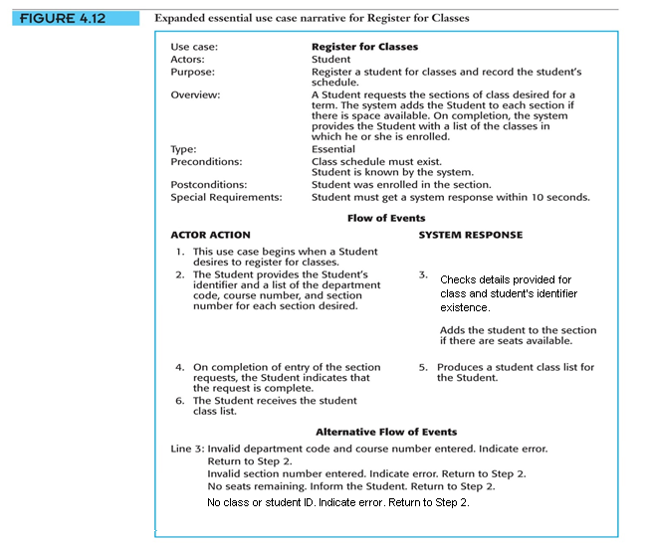Q2 Modify the use case narrative for **Register for Classes** to require that the system check prerequisites before adding a student to a class

Q3 Draw a system sequence diagram for the typical flow of events for the use case **Submit Department Class schedule**.

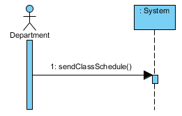  
  
  
Q4 Draw a system sequence diagram for the use case **Check out library Book**.

